**ER DIAGRAM**

**Conceptual Diagram:**

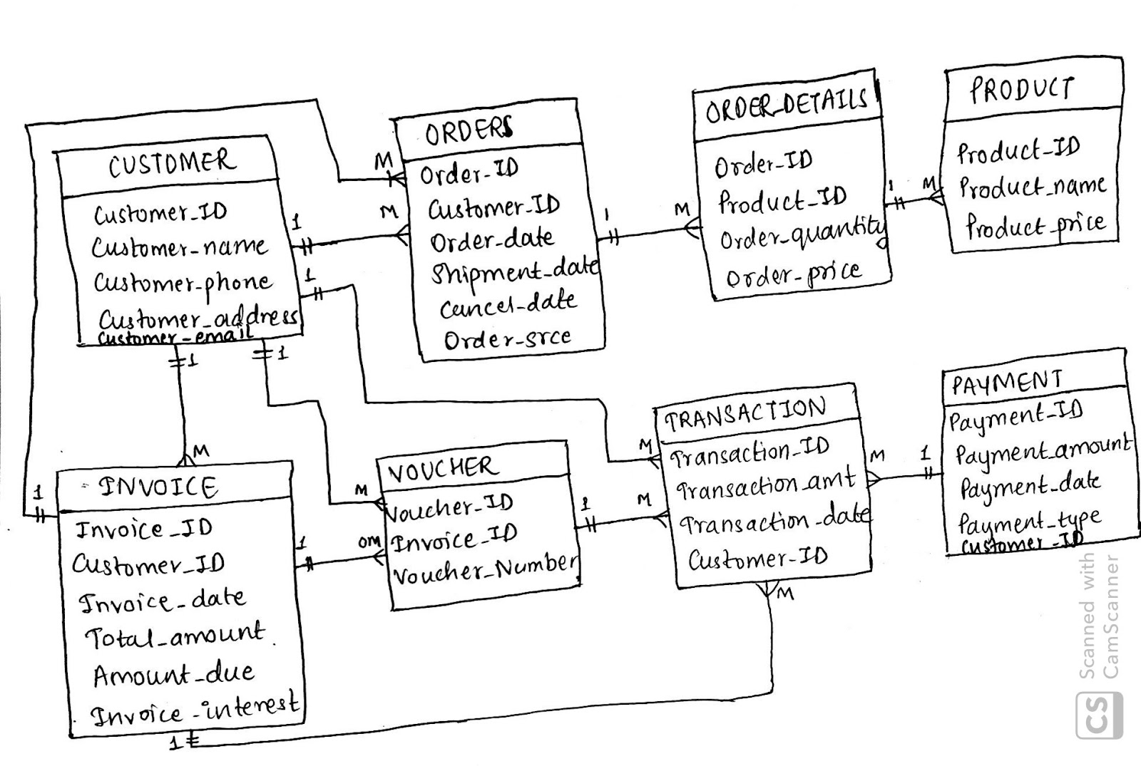

**Logical Diagram:**

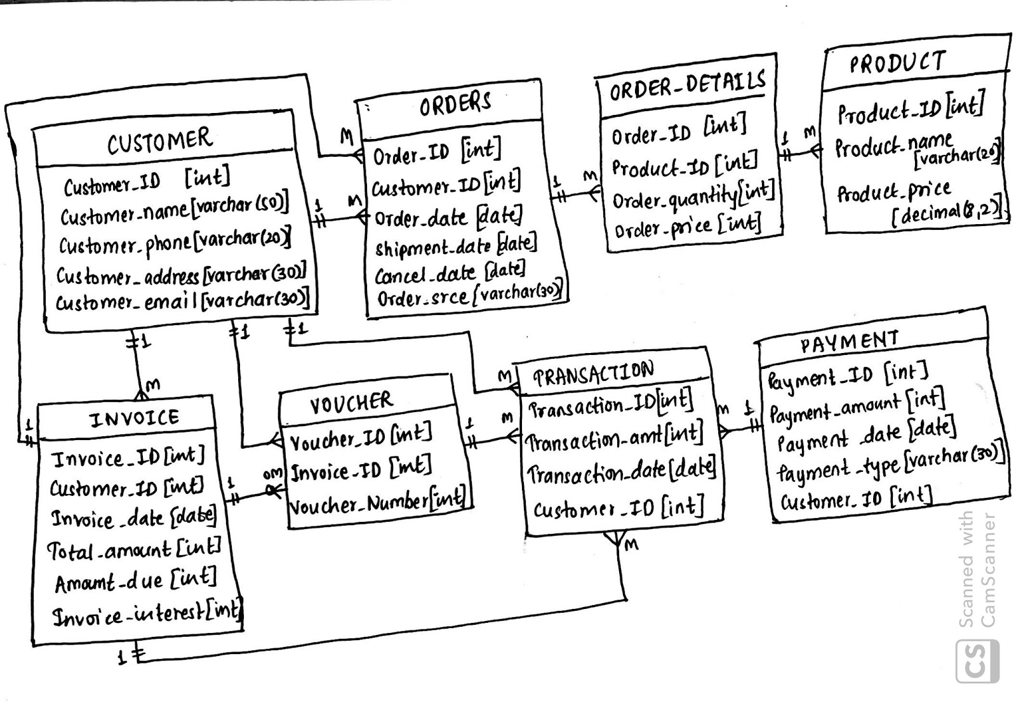**Physical Diagram:**

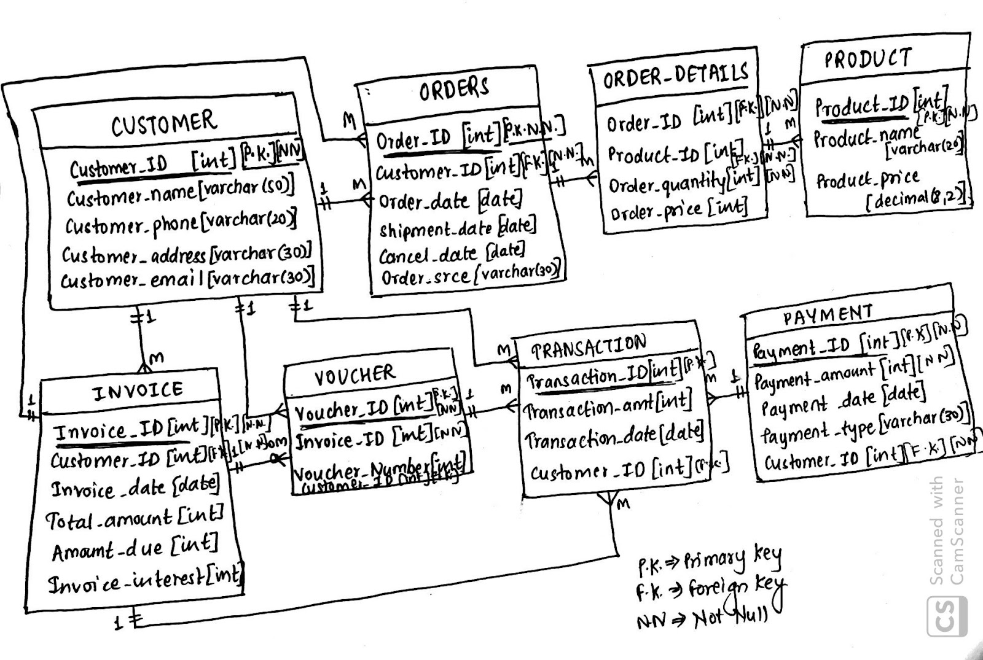

**CODE**

**DDL Query:**

**CREATE TABLE Customer**

**(**

**Customer_ID int not null,**

**Customer_name nvarchar(25),**

**Customer_phone nvarchar(25),**

**Customer_email varchar(50),**

**Customer_address varchar(30),**

**CONSTRAINT Customer_PK primary key (Customer_ID),**

**);**

**CREATE TABLE Orders**

**(**

**Order_ID int not null,**

**Customer_ID int not null,**

**Order_date Date,**

**Shipment_date Date,**

**Cancel_date Date,**

**Order_srce varchar(30),**

**CONSTRAINT Order_PK PRIMARY KEY (Order_ID),**

**CONSTRAINT Order_FK2 FOREIGN KEY (Customer_ID) REFERENCES [Customer] (Customer_ID)**

**);**

**CREATE TABLE Product**

**(**

**Product_ID int not null,**

**Product_name varchar(20),**

**Product_price DECIMAL(8,2),**

**CONSTRAINT Product_PK PRIMARY KEY (Product_ID)**

**);**

**CREATE TABLE Order_Details**

**(**

**Order_ID int not null,**

**Product_ID int not null,**

**Order_quantity int not null,**

**Order_Price int,**

**CONSTRAINT Order_DetailsFK1 FOREIGN KEY (Order_ID) REFERENCES [Orders] (Order_ID),**

**CONSTRAINT Order_DetailsFK2 FOREIGN KEY (Product_ID) REFERENCES [Product] (Product_ID),**

**);**

**CREATE TABLE Invoice**

**(**

**Invoice_ID int not null,**

**Customer_ID int not null,**

**Invoice_date Date,**

**Total_amount int,**

**Amount_due int,**

**Invoice_interest int,**

**CONSTRAINT Invoice_PK PRIMARY KEY (Invoice_ID),**

**CONSTRAINT Invoice_FK FOREIGN KEY (Customer_ID) REFERENCES [Customer] (Customer_ID),**

**);**

**CREATE TABLE Voucher**

**(**

**Voucher_ID int not null,**

**Invoice_ID int not null,**

**Voucher_Number int,**

**Customer_ID INT,**

**CONSTRAINT Voucher_PK PRIMARY KEY (Voucher_ID),**

**CONSTRAINT Voucher_FK FOREIGN KEY (Invoice_ID) REFERENCES [Invoice] (Invoice_ID),**

**constraint Voucher_FK2 FOREIGN KEY (Customer_ID) REFERENCES [Customer](Customer_ID)**

**);**

**CREATE TABLE Transactions**

**(**

**Transaction_ID int not null,**

**Transaction_amount int not null,**

**Transaction_date DATE,**

**Customer_ID int not null,**

**CONSTRAINT Transaction_PK PRIMARY KEY (Transaction_ID),**

**CONSTRAINT Transaction_FK FOREIGN KEY (Customer_ID) REFERENCES [Customer] (Customer_ID),**

**);**

**CREATE TABLE Payment**

**(**

**Payment_ID int not null,**

**Payment_amount int not null,**

**Payment_date DATE,**

**Payment_type VARCHAR(30),**

**Customer_ID int not NULL,**

**CONSTRAINT Payment_PK PRIMARY KEY (Payment_ID),**

**Constraint Payment_FK1 FOREIGN KEY (Customer_ID) REFERENCES [Customer] (Customer_ID)**

**);**

**DML Query:**

**Insert into Customer** [**VALUES(001,N'Aishwarya',N'345678980',N'aishu@gmail.com',N'165**](mailto:VALUES(001,N'Aishwarya',N'345678980',N'aishu@gmail.com',N'165) **Boston');**

**Insert into Customer** [**VALUES(002,N'Sonali',N'1234567',N'sonali@gmail.com',N'170**](mailto:VALUES(002,N'Sonali',N'1234567',N'sonali@gmail.com',N'170) **Chennai');**

**Insert into Customer** [**VALUES(003,N'Preethi',N'2345789',N'preethi@gmail.com',N'534**](mailto:VALUES(003,N'Preethi',N'2345789',N'preethi@gmail.com',N'534) **Pune');**

**Insert into Customer** [**VALUES(004,N'Vivian',N'2372638',N'vivi@gmail.com',N'242**](mailto:VALUES(004,N'Vivian',N'2372638',N'vivi@gmail.com',N'242) **Hydrebad');**

**Insert into Customer** [**VALUES(005,N'Harshitha',N'36482829',N'harshi@gmail.com',N'423**](mailto:VALUES(005,N'Harshitha',N'36482829',N'harshi@gmail.com',N'423) **Banglore');**

**Insert into Customer** [**VALUES(006,N'Tarun',N'34768462',N'tarun@gmail.com',N'2313**](mailto:VALUES(006,N'Tarun',N'34768462',N'tarun@gmail.com',N'2313) **Seattle');**

**Insert into Customer** [**VALUES(007,N'Saikumar',N'247284792',N'sai@gmail.com',N'33**](mailto:VALUES(007,N'Saikumar',N'247284792',N'sai@gmail.com',N'33) **Newyork');**

**Insert into Customer** [**VALUES(008,N'John',N'34686482',N'john@gmail.com',N'234**](mailto:VALUES(008,N'John',N'34686482',N'john@gmail.com',N'234) **Boston');**

**Insert into Customer** [**VALUES(009,N'Jack',N'7895522',N'jack@gmail.com',N'2890**](mailto:VALUES(009,N'Jack',N'7895522',N'jack@gmail.com',N'2890) **Boston');**

**Insert into Customer** [**VALUES(010,N'Andrew',N'6789234',N'andrew@gmail.com',N'2422**](mailto:VALUES(010,N'Andrew',N'6789234',N'andrew@gmail.com',N'2422) **Mumbai');**

**select* from Customer;**

**OUTPUT:**

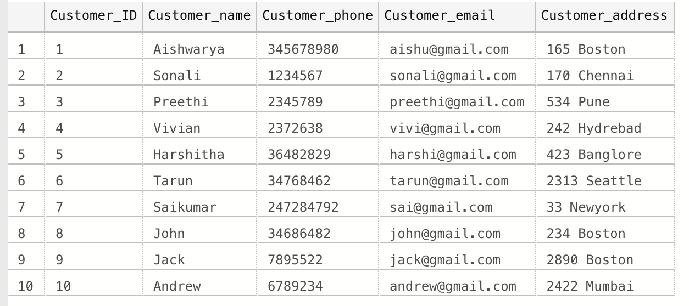

**Insert into Orders VALUES(101,001,2019-11-15,2019-11-16,2019-11-20,N'Material');**

**Insert into Orders VALUES(102,002,2019-10-15,2019-10-16,2019-10-20,N'Car');**

**Insert into Orders VALUES(103,003,2019-09-01,2019-09-03,2019-09-10,N'Electronics');**

**Insert into Orders VALUES(104,004,2019-11-15,2019-11-16,2019-11-20,N'Material');**

**Insert into Orders VALUES(105,005,2019-08-11,2019-08-13,2019-08-20,N'Electronics');**

**Insert into Orders VALUES(106,006,2019-07-20,2019-07-21,2019-07-25,N'Material');**

**Insert into Orders VALUES(107,007,2019-11-03,2019-11-05,2019-11-08,N'Car');**

**Insert into Orders VALUES(108,008,2019-06-15,2019-06-16,2019-06-19,N'Electronics');**

**Insert into Orders VALUES(109,009,2019-11-09,2019-11-10,2019-11-15,N'Clothing');**

**Insert into Orders VALUES(110,010,2019-07-15,2019-07-18,2019-07-20,N'Electronics');**

**Insert into Orders VALUES(111,001,2019-11-20,2019-11-21,2019-11-23,N'Material');**

**Insert into Orders VALUES(112,003,2019-09-15,2019-09-16,2019-09-20,N'Electronics');**

**Insert into Orders VALUES(113,005,2019-08-18,2019-08-19,2019-08-20,N'Electronics');**

**Insert into Orders VALUES(114,007,2019-11-10,2019-11-11,2019-11-15,N'Car');**

**Insert into Orders VALUES(115,009,2019-11-15,2019-11-16,2019-11-18,N'Clothing');**

**select* from Orders;**

**OUTPUT:**

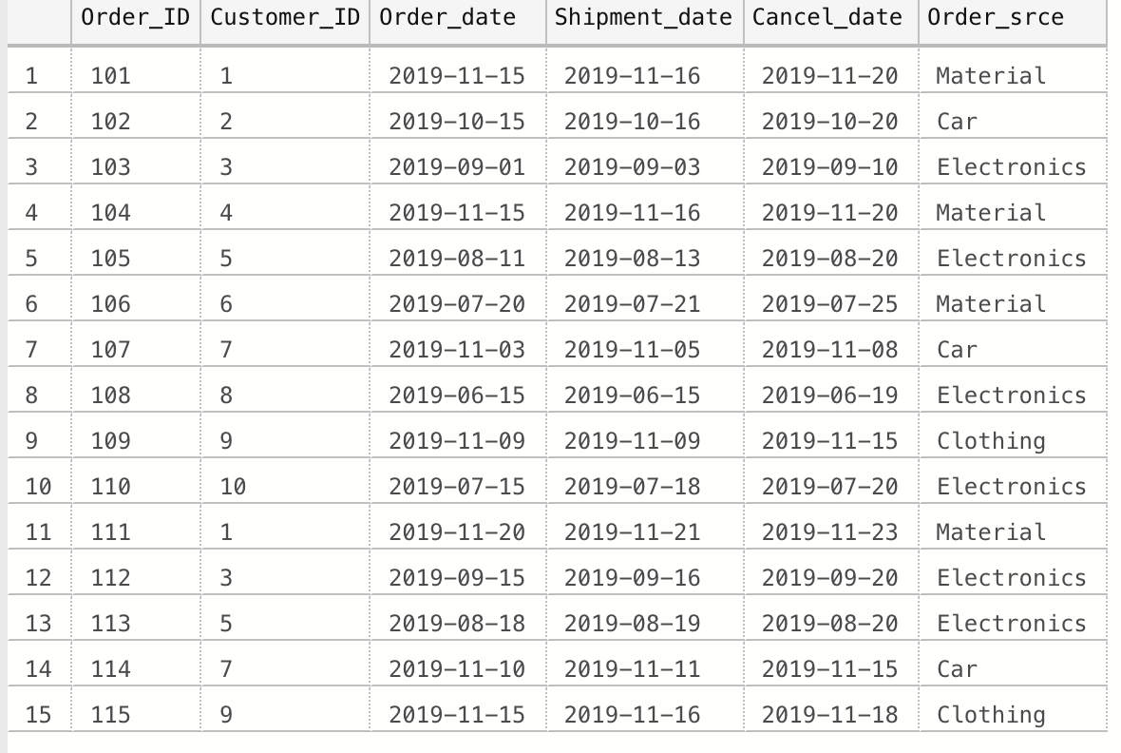

**Insert into Product VALUES(711,N'Laptop',50000);**

**Insert into Product VALUES(712,N'Camera',20000.99);**

**Insert into Product VALUES(713,N'Shoe',5000)**

**Insert into Product VALUES(714,N'Phone',80000.99);**

**Insert into Product VALUES(715,N'Headphone',30000);**

**Insert into Product VALUES(716,N'car',500000);**

**Insert into Product VALUES(717,N'Tab',10000);**

**Insert into Product VALUES(718,N'car',200000);**

**Insert into Product VALUES(719,N'Fitbit',10000);**

**Insert into Product VALUES(720,N'Laptop',25300);**

**Insert into Product VALUES(721,N'Iphone',25000);**

**Insert into Product VALUES(722,N'Desktop',30000);**

**Insert into Product VALUES(723,N'Fitbit',30200);**

**Insert into Product VALUES(724,N'Laptop',35000);**

**Insert into Product VALUES(725,N'Bluetooth Headphone',20000);**

**select* from Product;**

**OUTPUT:**

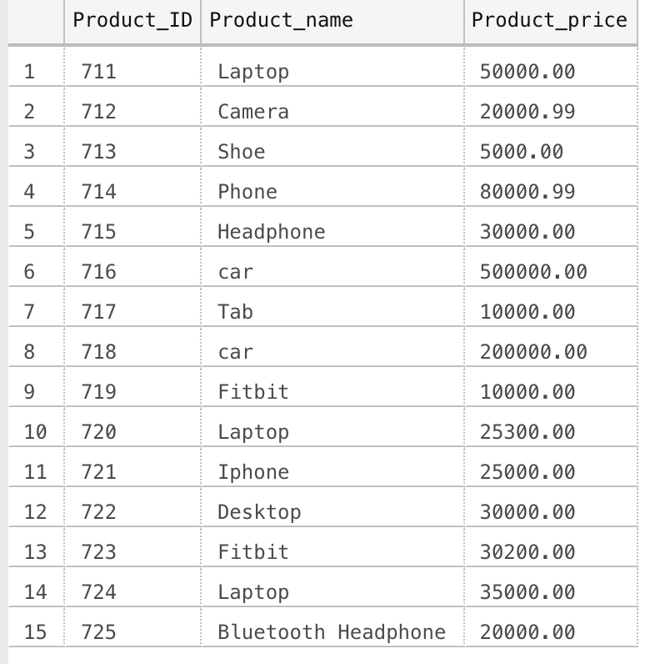

**Insert into Voucher VALUES(911,501,1);**

**Insert into Voucher VALUES(912,502,1);**

**Insert into Voucher VALUES(913,503,2);**

**Insert into Voucher VALUES(914,504,0);**

**Insert into Voucher VALUES(915,505,0);**

**Insert into Voucher VALUES(916,506,1);**

**Insert into Voucher VALUES(917,507,1);**

**Insert into Voucher VALUES(918,508,2);**

**Insert into Voucher VALUES(919,509,1);**

**Insert into Voucher VALUES(920,510,0);**

**Insert into Voucher VALUES(921,511,0);**

**Insert into Voucher VALUES(922,512,1);**

**Insert into Voucher VALUES(923,513,0);**

**Insert into Voucher VALUES(924,514,0);**

**Insert into Voucher VALUES(925,515,1);**

**select * from Voucher**

**OUTPUT:**

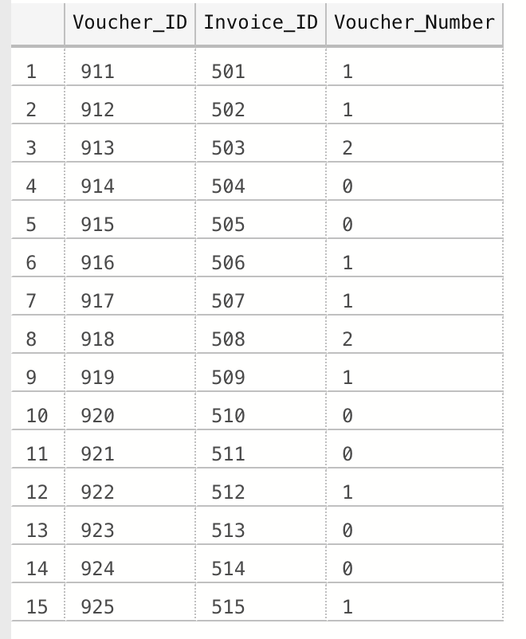

**Insert into Transactions VALUES(201,30000,'2019-11-19',001);**

**Insert into Transactions VALUES(202,25000,'2019-11-22',001);**

**Insert into Transactions VALUES(203,20000,'2019-10-20',002);**

**Insert into Transactions VALUES(204,2000,'2019-10-15',003);**

**Insert into Transactions VALUES(205,15000,'2019-10-20',003);**

**Insert into Transactions VALUES(206,80000,'2019-11-16',004);**

**Insert into Transactions VALUES(207,30000,'2019-08-11',005);**

**Insert into Transactions VALUES(208,30200,'2019-08-16',005);**

**Insert into Transactions VALUES(209,500000,'2019-07-21',006);**

**Insert into Transactions VALUES(210,5000,'2019-12-03',007);**

**Insert into Transactions VALUES(211,10500,'2019-12-15',007);**

**Insert into Transactions VALUES(212,200000,'2019-06-15',008);**

**Insert into Transactions VALUES(213,5000,'2019-12-09',009);**

**Insert into Transactions VALUES(214,12000,'2019-12-15',009);**

**Insert into Transactions VALUES(215,25300,'2019-07-15',010);**

**select * from Transactions;**

**OUTPUT:**

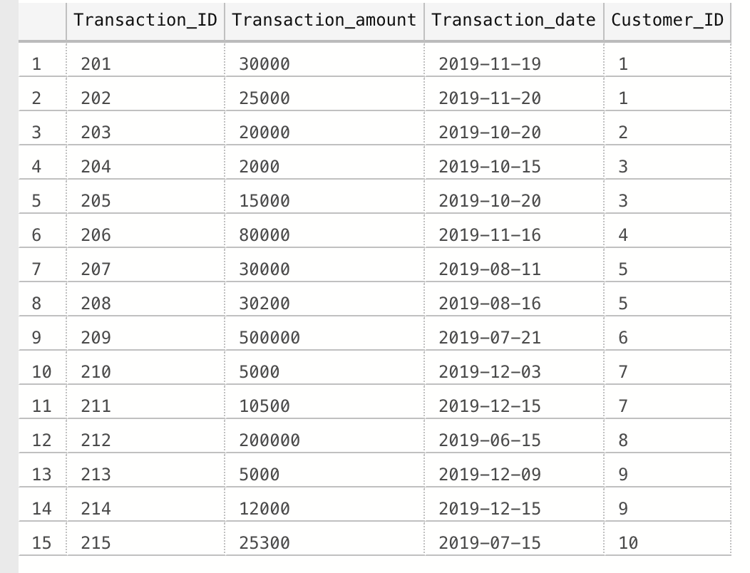

**Insert into Payment VALUES(301,30000,'2019-12-19',N'Wire transfer',001);**

**Insert into Payment VALUES(302,20000,'2019-10-20',N'Wire transfer',002);**

**Insert into Payment VALUES(303,2000,'2019-10-15',N'Wire transfer',003);**

**Insert into Payment VALUES(304,8000,'2019-11-16',N'Check',004);**

**Insert into Payment VALUES(305,30000,'2019-08-11',N'Wire transfer',005);**

**Insert into Payment VALUES(306,500000,'2019-07-21',N'Wire transfer',006);**

**Insert into Payment VALUES(307,105000,'2019-12-15',N'Wire transfer',007);**

**Insert into Payment VALUES(308,200000,'2019-06-15',N'Check',008);**

**Insert into Payment VALUES(309,12000,'2019-12-15',N'Wire transfer',009);**

**Insert into Payment VALUES(310,25300,'2019-07-15',N'Check',010);**

**select * from Payment;**

**OUTPUT:**

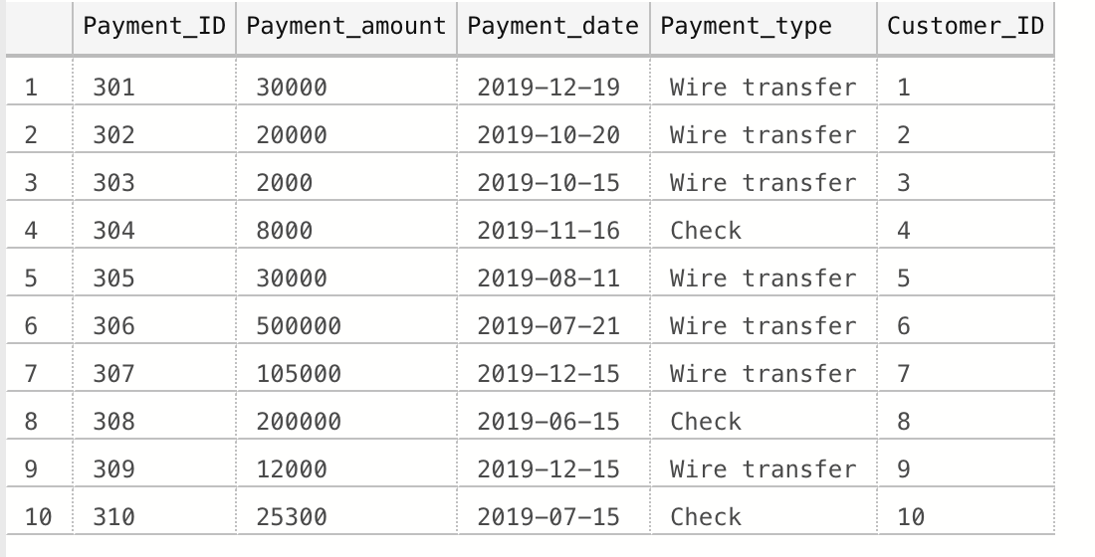

1) How do I automate the order consolidation and sales invoice generation which I have been doing manually?

Query:

(using stored procedure)

go

create procedure sp_generateInvoice

AS

insert into Invoice(Invoice_ID,Customer_ID,Invoice_date,Total_amount,Amount_due)

select row_number() over (order by customerID),Customer_id,TO_DATE('12/31/2019', 'MM/DD/YYYY'),Order_price,0 from Orders a

inner join Order_Details b

on a.Order_ID=b.Order_ID

where ([GETDATE]-Order_date) < 5

AND

Customer_ID not in (select Customer_ID from Voucher where Customer_ID=a.Customer_ID)

GROUP by Customer_ID

GO

**Output:**

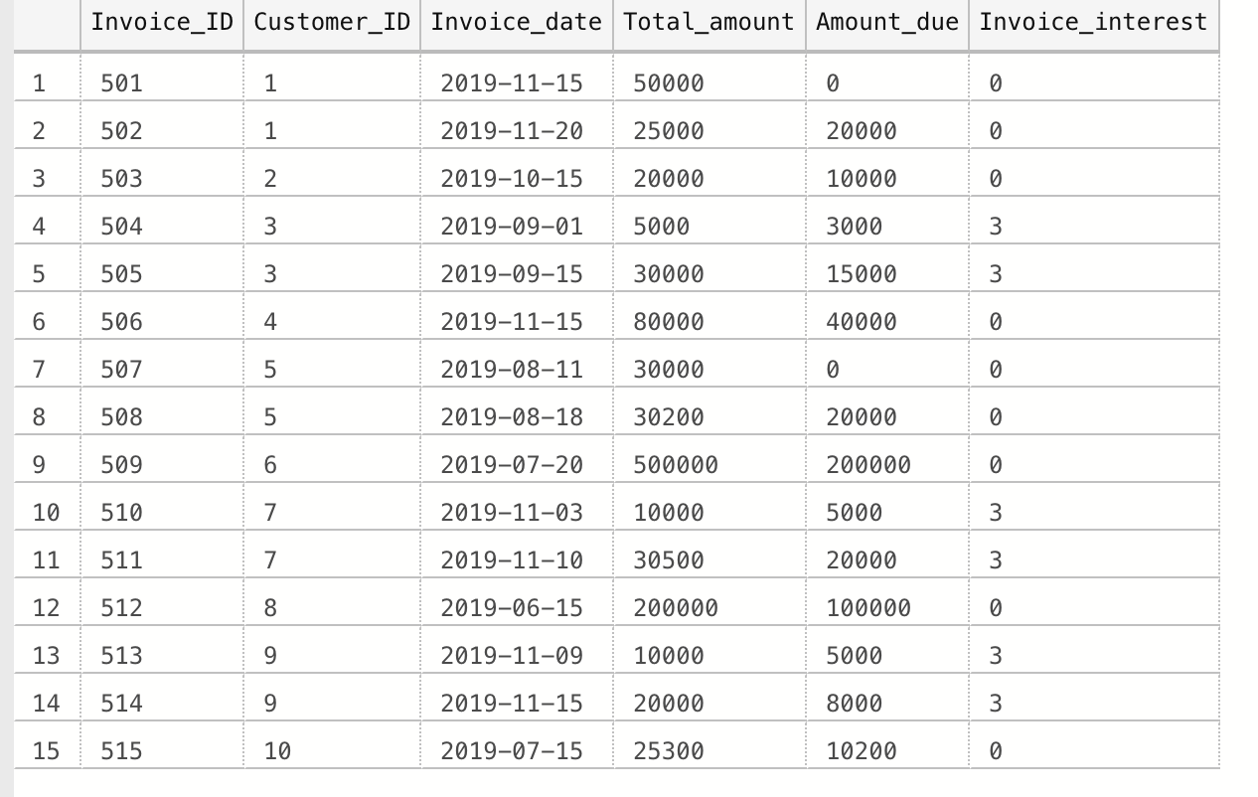

2. What are the five customers performing well by paying all invoices within 30 days?

**Query:**

**GO**

**Create PROCEDURE Customer_Invoice**

**As**

**Select distinct(customer.Customer_ID),Customer.Customer_name,Orders.Order_srce,Payment.Payment_amount**

**from Customer**

**INNER JOIN Orders**

**on Customer.Customer_ID=Orders.Customer_ID**

**INNER JOIN Payment**

**on Customer.Customer_ID=Payment.Customer_ID**

**WHERE datediff(day,Orders.Order_date,Payment.Payment_date) < 31**

**GO**

**exec Customer_Invoice**

**Output:**

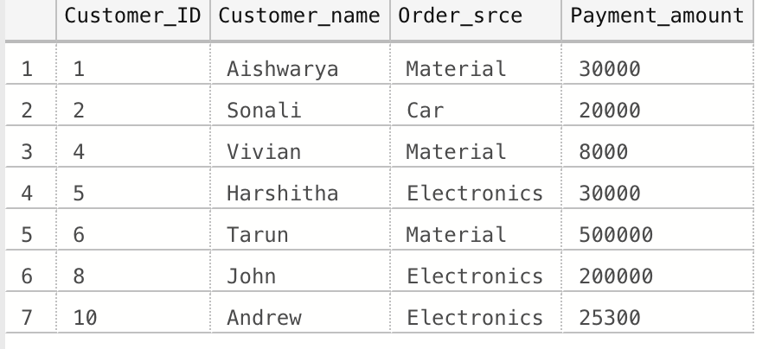

3. What are the five customers performing poorly by not paying all of the invoices within 30 days?

**Query:**

**GO**

**Create PROCEDURE Customer_Invoice1**

**As**

**select distinct(customer.Customer_ID),Customer.Customer_name,Orders.Order_srce,Payment.Payment_amount**

**from Customer**

**INNER JOIN Orders**

**on Customer.Customer_ID=Orders.Customer_ID**

**INNER JOIN Payment**

**on Customer.Customer_ID=Payment.Customer_ID**

**WHERE datediff(day,Orders.Order_date,Payment.Payment_date) > 31**

**GO**

**exec Customer_Invoice1**

**OUTPUT:**

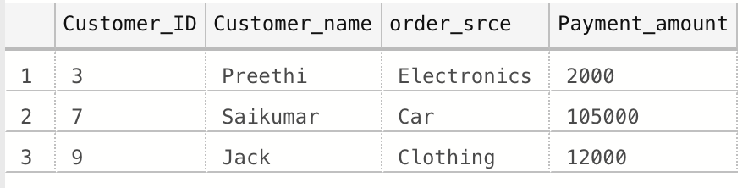

4. What are the customers performing well by clearing the accrued interest before placing further orders?

**Query:**

**GO**

**Create PROCEDURE Customer_Int**

**As**

**SELECT Customer_name,Invoice_ID**

**from Customer C**

**INNER JOIN Invoice I**

**on C.Customer_ID=I.Customer_ID where I.Amount_due=0**

**go**

**EXEC Customer_Int**

**Output:**

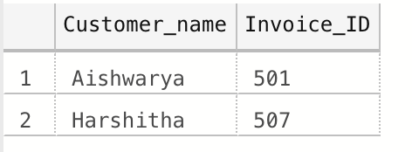

5. What are the customers performing poorly by not clearing the accrued interest before placing further orders?

**Query:**

**GO**

**Create PROCEDURE Customer_Int2**

**As**

**SELECT Customer_name,Invoice_ID**

**from Customer C**

**INNER JOIN Invoice I**

**on C.Customer_ID=I.Customer_ID where I.Amount_due!=0**

**go**

**EXEC Customer_Int2**

**Output:**

